# The optimal Virtual Reality bar location in Ontario, North York

## The business problem

Virtual reality is booming and ready to change the gaming industry. However the gaming equipment is still quite expensive. The idea is to open a virtual reality bar in North York (Ontario), to make virtual reality games more widespread, more accessible for everyone. The main assumption is that the biggest part of the potential VR gamers is to be found among young people that still go to school. So, first of all we will look at the presence of schools in North York and their student enrollments to identify the biggest concentrations of possible clients. Furthermore, we would also like to avoid any other virtual reality/gaming centers nearby. We may also like to give a lower weight to schools with a higher enrollment of lower house-hold incomes as these have less free money to spend. At a later stage we may cluster schools according to profitablility.

## Data

School data will be taken from the government site of Ontario, which can be found at the following link:<https://www.ontario.ca/data/school-information-and-student-demographics>. It provides data on all publicly funded schools in Ontario, including school board, school address, provincial test results, student population demographics and class sizes. Important for our assumption is the address of the school and the number of students and Percentage of Children Who Live in Low-Income Households.

Using Fouresquare we are able to meet the second condition, namely avoiding nearby virtual reality/ gaming centers. By passing the location of the different schools to the foursquare location data search engine we can have an overview of the nearby virtual reality/ gaming centers per school.

## Methodology

First of all, we will collect al necessary data ( student enrollment, school coordinates, % of children who live in low-income households) & clean it. Than we will identify the virtual reality / gaming centers via het foursquare search engine within a radius of 3 km in North York. We do this via the search engine and pass as searching words “Virtual” & “gaming”. Note that we have some unrelevant data here, especially Virtual Schools. So, I exclude these explicitly from my extraction.

We will define the number of available students per school as

student enrollment per school

--------------------------------------------

Nbr. of nearby VR/gaming centers + 1

The 1 in the denominator reflecting our own future VR bar.

At a later stage we will custer the data according to profitbability using the KMeans algorithm.

We would like to have 6 different clusters (to be defined) of our features: available students , number of nearby gaming centers &% of children in Low-Income households. Note I initially also extracted the % of parents with a university degree but decided to drop this variable as there seems to be a strong correlation between the % of children in Low-Income households & % of parents with a university degree.

## Outcome

The outcome reveals that the cluster with the highest potential is the red cluster in North York.

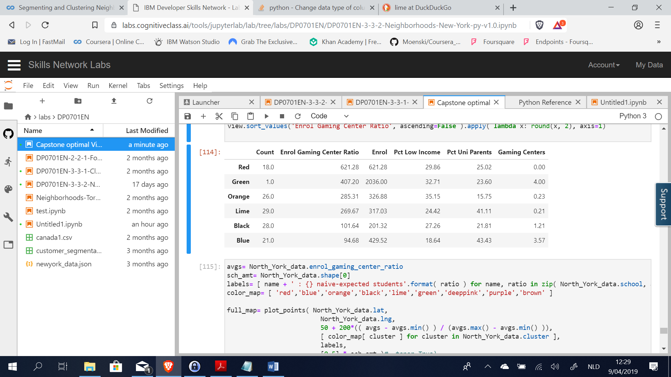

This can be found in West and East North York. Note that the biggest number of students are enrolled in the green cluster but this cluster has 4 nearby gaming centers. Furthermore, you can observe that the enrol gaming center ratio & average in number of nearby gaming centers for the orange and lime clusters are more or less of the same magnitude but the % of households with a low income is substantially lower in the lime cluster (24%) vs. the orange cluster ( 35%).

So, based on this additionnal information I would advise to open a Virtual reality bar in the East of North York.

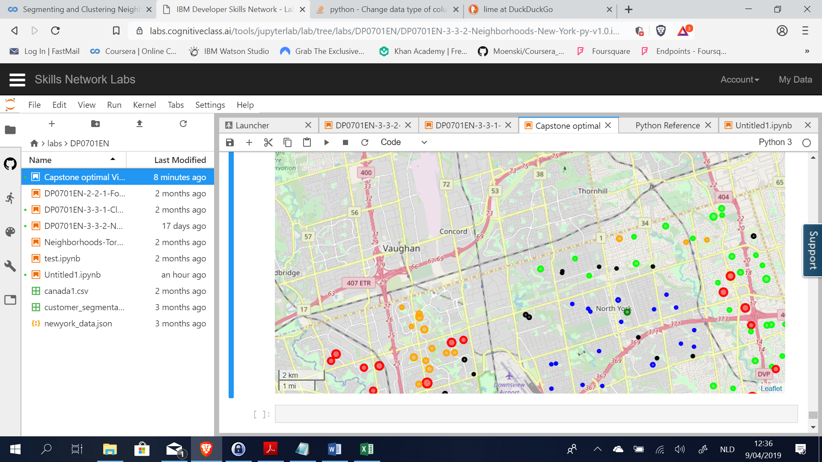

Note that this study can be further extended by:

* Refining the search terms used in the Foursquare search engine + extend the search radius
* Enlarge the scope to the state Ontario
* ….